**Discrete Mathematical Structures**

**Week-8**

**Long Descriptive Questions**

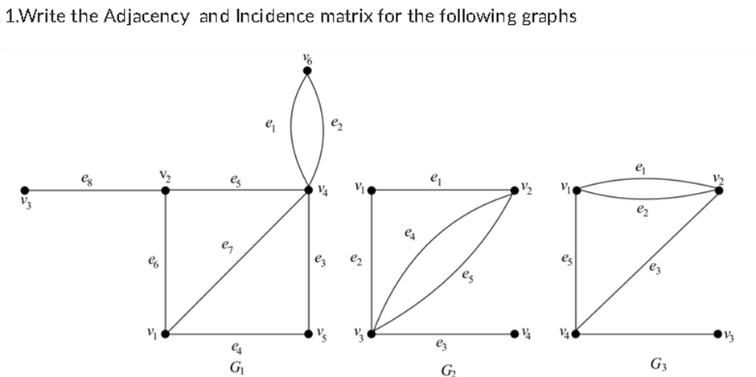

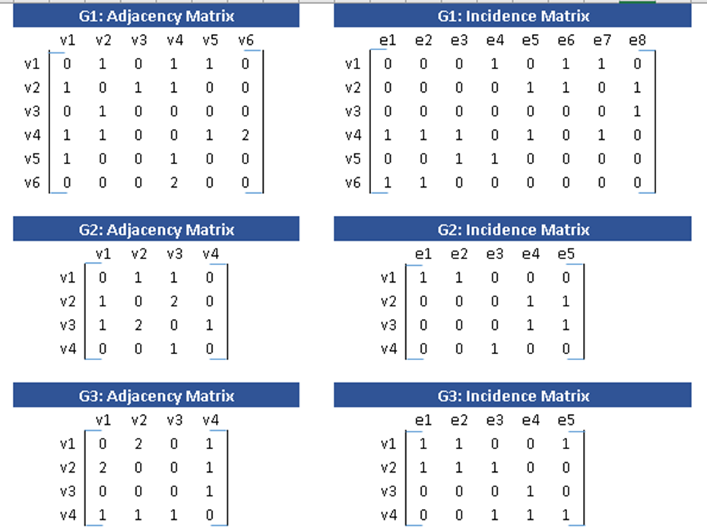

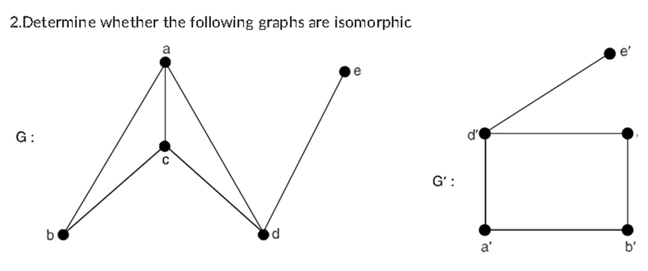

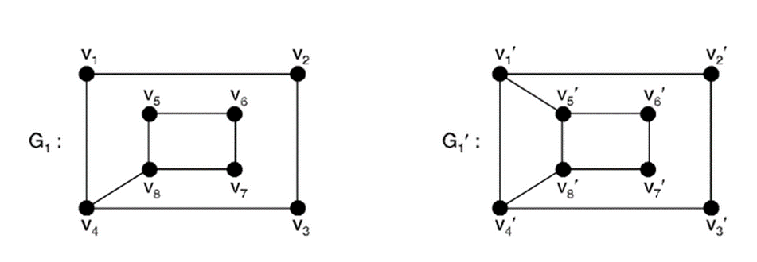

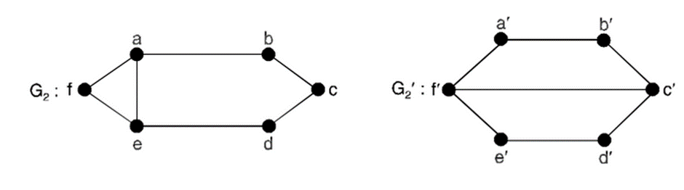

To determine whether a graph is an isomorphic, it needs to fulfil three criteria-

* Both must have the same number of vertices.
* Both must have the same number of edges.
* Both must have equal number of vertices with the same degree.
* They must have the same degree sequence and same cycle vector (c1, c2, ..., cn),

where ci is the number of cycles of length i.

1. The graph G & G’ : Since they don’t have equal number of edges hence they are not isomorphic.

Number of vertices = 5 for both however edges are not equal.

Graph G has 6 edges but G’ has 5; Hence not Isomorphic.

1. The graph G1 & G1’: Here also they don’t have equal number of edges hence they are not isomorphic.

Number of vertices = 8 for both however again edges are not equal.

Graph G1 has 9 edges while G1’ has 10; Hence not Isomorphic.

1. The graph G2 & G2’: Here the degree of corresponding vertices don’t match, hence not Isomorphic.

Number of vertices are same for both, which is 6

Number of edges are same for both, which is 7

However since in graph G2 the vertex c has two degree while the corresponding vertex c’ in graph G2’, has three degree and since this is clearly not equal hence these graph are also not Isomorphic.